**Learn in Community**

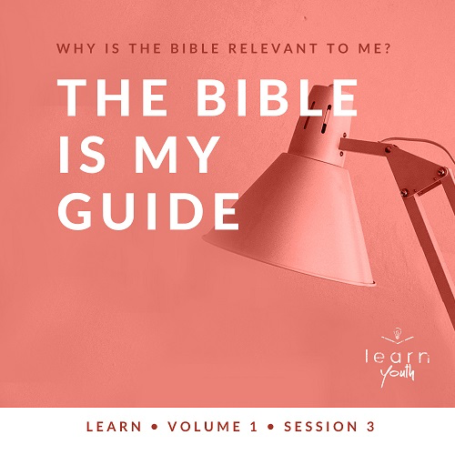

Small Group Study

**Volume Overview**

**Why is the Bible relevant to me?**

*All Scripture is inspired by God and is useful to teach us what is true and to make us realize what is wrong in our lives. It corrects us when we are wrong and teaches us to do what is right. (*[*2 Timothy 3:16*](https://ref.ly/logosref/Bible.2Ti3.16)*)*

*Let’s be honest—the Bible can feel confusing. It’s a collection of sixty-six different books written in three different languages by over forty different authors spanning multiple genres and time periods. Also, some issues in the Bible appear foreign compared to the issues we face in our world today. So, how does the Bible apply to us? In these sessions, we’ll look at what the Bible really is and how it is vital for us as we follow Jesus.*

|  |
| --- |
| **You Will Need**   * Blindfolds, one per team * Several pieces of plain paper * Optional: Small prize for the winning team * Flashlight or phone with light   **Getting Ready**   * Set up a time trial course by placing pieces of paper randomly on the floor (or ground) as checkpoints for students to step on. This can be done inside or outside your meeting room. * First time leading *Learn* for Youth? Look here for the [Facilitator Guide](https://0b769b0ed3569ef9d18b-f88d8272f61086866d50d048b43ef630.ssl.cf2.rackcdn.com/sites/biblengagementproject/Listen_Facilitator_Guide.pdf). |

**Engage**

**Welcome**

*Take this time to welcome everyone, introduce new students, learn names, and thank everyone for coming.*

|  |
| --- |
| **QUESTION**  If you could eat at only one restaurant for the next year, which one would it be? |

**Opening Prayer**

*Prayer thoughts: Thank God for every student who is present and for the opportunity to gather together. Ask God to illuminate the Bible through the Holy Spirit so that students can understand it and apply it to their lives.*

**Introduction**

Today, we’re continuing our study of the Bible. We’ve already talked about how the Bible is God’s Word and how the Bible is true. Now let’s talk about how we can use the Bible as a guide for our life.

**Group Activity**

**Blindfolded Time Trials**

|  |
| --- |
| **You Will Need**   * Blindfolds, one per team * Several pieces of plain paper * Optional: Small prize for the winning team   **Getting Ready**   * Set up a time trial course by placing pieces of paper randomly on the floor (or ground) as checkpoints for students to step on. This can be done inside or outside your meeting room. |

Before we dive into our discussion, let’s test your communication skills in teams. One member of each team has to complete a simple walking course by hitting each checkpoint. These checkpoints are marked by pieces of paper on the ground. The team that completes the course the fastest wins.

Here’s the catch: the person competing on the course is blindfolded. The way to navigate the course is by listening to the guidance of your team members who will be telling you where to step. As they give verbal directions, complete the course by stepping on each piece of paper before moving to the next one.

• *Divide the group into teams of three to five, and blindfold one student from each team.*

• *Time them as they complete the course with the guidance of team members.*

• *Consider altering the course slightly after each team so that the route cannot be memorized by other teams.*

|  |
| --- |
| **QUESTION**  If you were blindfolded, how challenging was it to complete the course? Did hearing more than one voice make it harder? |

|  |
| --- |
| **QUESTION**  What advice would you give to a team who had yet to perform the task to make them successful? |

|  |
| --- |
| **QUESTION**  How much more difficult would the course be if you were blindfolded without a guide to help you? |

Trying to go through the course without a guide would be difficult, if not impossible. In the same way, we need a guide as we go through life, too. Lots of voices in the world are trying to tell us how to live, but many of them couldn’t care less about God or us. Let’s take a look at how the Bible is the right guiding voice to listen to as we follow God.

**Watch**

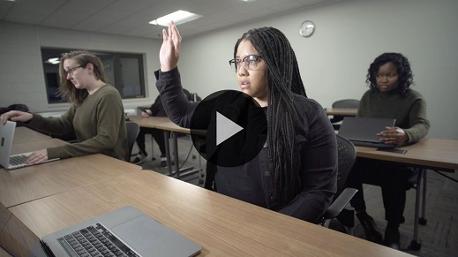

**Consider What the Bible Says**

*Ensure each student has access to a Bible, preferably the same version.*

|  |
| --- |
| **You Will Need**   * Flashlight or phone with light   **Getting Ready**  No prep is needed. |

Let’s take a moment to look at a story in which Jesus talks about the role Scripture can play in our lives when we respond to it the right way.

|  |
| --- |
| **QUESTION**  How many churches do you think are currently in our city? |

|  |
| --- |
| **QUESTION**  How many Bibles do you think the average Christian has in their home? |

In many countries, Jesus and Christianity are at least somewhat familiar to most people. If it’s not illegal to have a Bible, many of those people probably have more than one to choose from. But in the Bible passage we’re about to read, Jesus makes it clear that it’s not just about *knowing* what He says. *Doing* what He says makes all the difference.

**God’s Word Deserves Obedience**

Read [Luke 6:46–49](https://ref.ly/logosref/Bible.Lk6.46-49).

|  |
| --- |
| **QUESTION**  Think about the word Lord for a moment. What does it mean for Jesus to be Lord? |

Jesus used this bit of teaching to contrast two different types of people—those who do what He says and those who don’t. Those who really make Jesus their Lord follow His teachings. Here He taught that God’s Word makes a solid foundation for our lives, but only if we obey it.

|  |
| --- |
| **QUESTION**  According to Jesus, what foundation will withstand the storms? |

|  |
| --- |
| **QUESTION**  What does Jesus say is the end result of the person who hears God’s Word but doesn’t obey? |

Jesus taught that obeying God’s Word is the only foundation that will last. It doesn’t matter how rough life gets if your life is built on what the Bible says. You can get through it! The more we make the Bible our guide, the more we can obey it and enjoy the benefits of it being our life’s foundation.

|  |
| --- |
| **QUESTION**  What are some reasons why we don’t always obey God’s Word? |

**God’s Word Offers Security in Difficult Times**

Jesus uses a picture of a storm to represent the challenges of life. Notice how it says *when* the storms hit, not *if* the storms hit. Following Jesus and obeying what God’s Word says are not guarantees for life to be easy or for no bad things to happen. It’s a guarantee that when the storms of life come, we’ll have a firm foundation that will not collapse.

|  |
| --- |
| **QUESTION**  What are some storms we might face in our own lives? |

• *You may want or need to stop and minister to a student who is currently going through a difficult time. Don’t hesitate to take a few minutes to encourage and pray for them.*

|  |
| --- |
| **QUESTION**  When facing a storm in your life, do you find yourself turning to God’s Word? If not, why not? |

God’s Word is a trustworthy foundation. When we are obedient to do what He says, we can trust that no storm of life will crush us. That’s not all, though. God’s Word also guides us when life isn’t stormy.

**God’s Word Offers Guidance through Life**

Read [Psalm 119:101–105](https://ref.ly/logosref/Bible.Ps119.101-105).

|  |
| --- |
| **QUESTION**  Verse [105](https://ref.ly/logosref/Bible.Ps119.105) compares God’s Word to two different things. What are they? |

|  |
| --- |
| **QUESTION**  What does it mean that the Bible is a lamp to guide our feet? |

|  |
| --- |
| **QUESTION**  What are some things in your life you no longer do because the Bible has become a guide for you? |

**Illustration**

• *Grab your flashlight and turn it on. Then turn off all the lights.*

[Psalm 119:105](https://ref.ly/logosref/Bible.Ps119.105) tells us the Bible is like a light for us. It guides us by helping us see the right way to go through life. It also gives us security in knowing what’s around us. In the dark, we’re left to fumble our way around. We can’t see where it’s safe and where it’s dangerous. But God’s Word helps us to know exactly where to step.

•  *Turn on all the lights, and turn the flashlight off*.

|  |
| --- |
| **QUESTION**  Is anyone brave enough to share a time in your life when you were really afraid in the dark? |

|  |
| --- |
| **QUESTION**  What are some areas in life where you need guidance or help with decision-making? |

**Did You Know?**

|  |
| --- |
| In our English translations of the Bible, Jesus is usually called a carpenter. The word in Greek is *tecton*. It means a lot more than just woodworking. The term was more general for a builder who worked with a bunch of different materials. Wood was pretty rare in the land of Israel in those days, so most buildings used stone for construction instead. Due to the weight of stone, the job of a builder was an incredibly important and respected craft in the ancient world of the New Testament. It required significant skill in planning and problem-solving in order to create a structure that would be sound and safe.  Jewish communities often considered builders to be the most prominent thinkers, as a result of their required skills. If a judge, magistrate, or religious leader was not available to dissolve a dispute of legal or religious matter, the communities historically would turn to their resident *tecton*. |

**Reflect**

**The Bible Is My Guide**

In all seasons of life, obeying God’s Word puts us on the right path. When storms come, our obedience lays a foundation that is built to last and won’t wash away. When life isn’t so bad, we still need God’s Word to guide us on the right path. It will give direction for the decisions we face. And as we spend more time in Scripture, we’ll love God and His Word more just as David did ([Psalm 119:103](https://ref.ly/logosref/Bible.Ps119.103)).

**Listen to God**

Let’s take time to consider if we’re really using the Bible as a guide for our life. These questions are meant to serve as a conversation between you and God. Sharing your responses with the group is completely voluntary.

• *Pause for a few moments of silent reflection before asking students if they want to share.*

|  |
| --- |
| **QUESTION**  If a storm (challenge) hit your life, would your foundation be solid enough to stand firm? If not, what might need to change? |

|  |
| --- |
| **QUESTION**  What are you facing right now that needs the guidance of God’s Word? How can it become a light to help you see the right way to go? |

**Activate**

As we’ve talked about today, true guidance doesn’t just come by hearing or talking about God’s Word. We need to obey and do what it says. As we wrap up, let’s remember to listen as the Holy Spirit helps you apply God’s Word to your decisions this coming week.

|  |
| --- |
| **QUESTION**  What is one thing you believe God has been speaking to you about that you need to step out and do? Determine to obey the Lord and do it this week. |

|  |
| --- |
| **Salvation Opportunity**  *Include this if you think there may be some in the group who do not have a personal relationship with Jesus.*  The first step in building a sure foundation for life is to place our hope and trust in Jesus. We can only experience true peace, security, and guidance when Jesus is the Lord of our life. Jesus proved His love for us by living a perfect life and choosing to die on a cross to carry the weight of our sins. We can respond to that kind of love by committing our lives to Him.  **Is anyone here that we can pray for who doesn’t have a relationship with Jesus or wants to renew their relationship with Him?**  *Take a moment to acknowledge those who respond, and thank them for their desire to make things right between themselves and God. Pray with them as you close in prayer or after the group time is over. Following group time, talk more about where they are in their walk with God and how you might be able to help.* |

**Conclusion**

Jesus knew storms would come for everyone, even those who are fully committed to Him. He also knew that in the darkness of those storms we would need a guide to make right decisions in this life. That’s why He gave us His Word. It’s a sure foundation and a trustworthy guide, no matter what we might face. Now, it’s up to us to read it, listen to God’s teaching, and then do what He says to us through His Word.

Next time, we’ll finish up our discussions about the Bible by talking about how Scripture can become a weapon to overcome temptation. Your personal devotions for this week will lead into that, so don’t forget to do those!

**Prayer**

All-knowing God, thank You for Your love and commitment to us. Help us to build our lives on a lasting foundation. When we face tough decisions or need guidance, help us to look to You instead of trying to figure it out on our own. We trust Your Word to guide us. We ask that our family and friends grow in their obedience to Your Word as well. In Jesus’ name we pray. Amen.

Don’t forget to open the Bible Engagement app this week to find your personal devotions. These allow you to spend time in God’s Word on your own and put into practice the things we’ve been learning. I look forward to seeing each of you next time as we continue our journey in God’s Word.